**Experiment Title.**

**Student Name: Rahul maurya UID:20BCS7260**

**Branch: cse Section/Group:- 716 B**

**Semester: 3rd Date of Performance:**

**Subject Name:- mpi lab Subject Code: 30/4/2022**

1. **Aim/Overview of the practical:**

**Shift 16 bit number**

1. **Description/ Code:**

**#BEGIN5000 H**

**LHLD 2500**

**DAD H**

**SHLD 2502H**

**HLT**

**#ORG 2500**

**#DB 72,60**

**DOUBLE SHIFT**

**#BEGIN5000 H**

**LHLD 2500**

**DAD H**

**DAD H**

**SHLD 2502H**

**HLT**

**#ORG 2500**

**#DB 72,60**

1. **Result/Output/Writing Summary:**

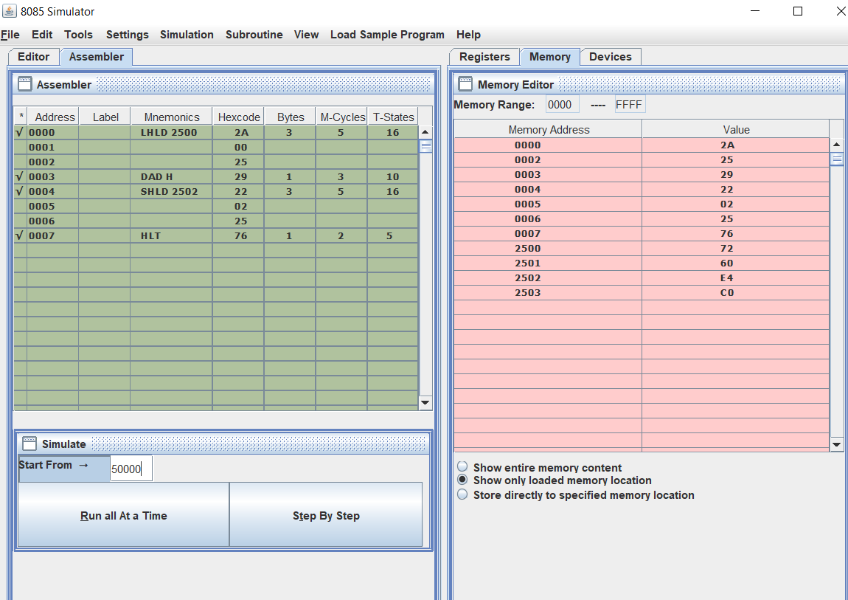

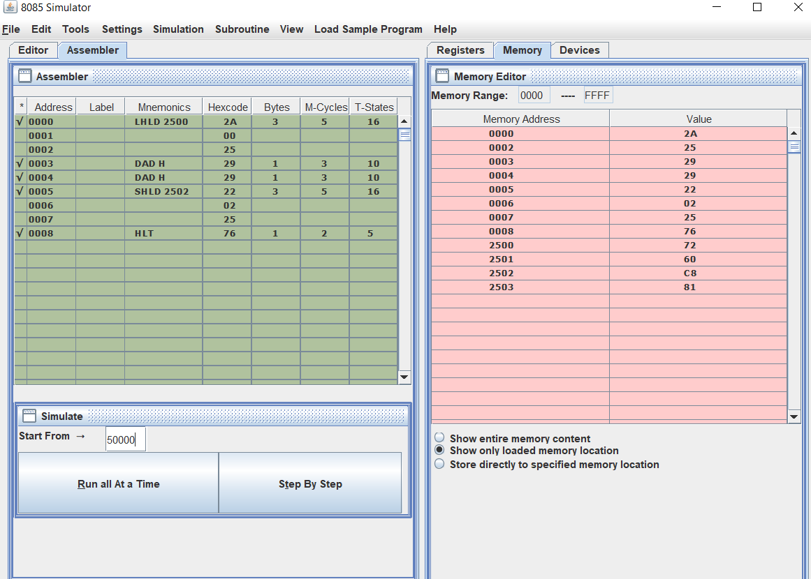

**Learning outcomes (What I have learnt):**

**1. learnt about shifting 16 bit number**

**2.learnt about double shifting 16 bit number**

**Evaluation Grid (To be created as per the SOP and Assessment guidelines by the faculty):**

|  |  |  |  |
| --- | --- | --- | --- |
| Sr. No. | Parameters | Marks Obtained | Maximum Marks |
| 1. |  |  |  |
| 2. |  |  |  |
| 3. |  |  |  |
|  |  |  |  |